Professional, Scientific, and Technical Services • 54161

Management Consulting in the US


Alexander Govdysh Published: June 2026

2026 IBISWorld. All Rights Reserved www.ibisworld.com

About

IBISWorld specializes in industry research with coverage on thousands of global industries. Our comprehensive data and in-depth analysis help businesses of all types gain quick and actionable insights on industries around the world. Busy professionals can spend less time researching and preparing for meetings, and more time focused on making strategic business decisions.

Table of Contents

1. Risk Overview ....................................................................................... | 1 | Volatility ....................................................................................................... | 7
Recent Developments ............................................................................. | 1 | 3. Growth Risk ......................................................................................... | 8
Industry Definition & Activities ............................................................. | 1 | Growth Risk Score .................................................................................. | 8
Industry Risk Score .................................................................................. | 2 | Growth Risk Analysis ............................................................................. | 8
Risk Rating Analysis ................................................................................. | 2 | 4. Sensitivity Risk .................................................................................... | 9
2. Structural Risk .................................................................................... | 5 | Sensitivity Risk Score .............................................................................. | 9
Structural Risk Score .............................................................................. | 5 | Sensitivity Risk Analysis ......................................................................... | 9
Barriers to Entry ....................................................................................... | 5 | 5. Risk Score Methodology .............................................................. | 24
Competition ............................................................................................... | 5 | What is Industry Risk? ......................................................................... | 24
Domestic And International Markets ................................................ | 6 | Industry Risk Scoring Methodology ............................................... | 24
Assistance .................................................................................................. | 6 | Risk Rating Score Ranges .................................................................. | 24
Life Cycle .................................................................................................... | 6

Risk Overview

Recent Developments

Companies Overview

Major companies offer various services beyond management consulting, allowing them to outcompete smaller firms, particularly with larger clients. Major companies such as Deloitte and Accenture PLC offer services such as technology consulting and sustainability assistance.
Small companies compete by specializing. By targeting niche markets or offering specific services, these firms can leverage deep expertise to effectively compete against larger companies for client business.

Competitive Forces

Competition will tighten the industry's overall profitability. As technology impacts clients' businesses and boosts consulting demand, companies will need to spend more on skilled workers and automated infrastructure to keep up with external competitors.
Fewer new management consultants will lead to a more concentrated market. Slower growth underscores the advantages of larger companies, while mergers allow smaller companies to combine resources and achieve economies of scale.

External Environment

Minimal barriers to entry spur competition for skilled employees in labor-intensive industries. With no significant obstacles to starting a business, the race for seasoned, highly trained and connected workers intensifies.
Consultants must be skilled in new technologies. Expert knowledge of industry advances is crucial for providing sound advice and overseeing the implementation of client processes and procedures.

Financial Benchmarks

Exorbitant operational costs and in-house competition will continue to impact profit. Although technology will enhance service quality, consulting remains labor-intensive, making wage expenses the most significant factor affecting profitability.
Competition for skilled workers will drive higher wages. Thanks to access to a global labor pool, remote work enables smaller consultancies to compete with large companies and international firms for talent.

Geographic Breakdown

Consulting firms are primarily located in population centers like the Mid-Atlantic and the West. Major cities like Los Angeles and New York City are home to considerable business activity, enabling a lucrative and consistent regional demand stream for consultancies.
Florida houses a significant share of management consulting firms. The Southeast leads the nation in the number of these firms, with Florida representing the majority in the region due to its favorable tax environment and heavy financial sector presence.

Performance

Product and market variety continue to generate consistent consultant performance. Serving diverse downstream clients, such as financial and industrial companies and offering services ranging from technical to strategic support, ensures revenue growth for management consultants, even during economic fluctuations.
The technology tide heightens the need for skilled workers. The greater proliferation of automated technology and expansion of digital business solutions will drive higher competition among technically skilled consultants.

Products Markets

Providing corporate strategy services remains a popular and wide-ranging service. These services see the greatest demand among consulting offerings and are a key driver of client growth irrespective of their sector or business.
Client diversification opens niche opportunities. Serving a diverse client base, from private financial companies to public government organizations, allows consultants to specialize in niche consulting offerings and creates consistent revenue streams.

Industry Definition & Activities

Definition

Operators in the industry advise businesses, nonprofits and public-sector agencies in areas such as organizational planning design, human

resources policies, practices and planning, corporate strategy, information technology strategy, marketing and sales, financial planning and budgeting and logistics.

The primary activities of this industry are:

- Strategic management consulting, and consulting combined with implementation
- Financial management consulting, and consulting combined with implementation
- Marketing management consulting, and consulting combined with implementation
- Human resources management consulting, and consulting combined with implementation
- Operations and supply chain management consulting, and consulting combined with implementation
- Actuarial consulting (except for employee pensions and other benefits)
- IT technical design, consulting, and development services
- Organizational development

Industry Risk Score

Risk Component | Level | Weight (%) | Score
Structural risk | Medium | 25 | 4.8
Growth risk | Medium - High | 25 | 5.6
Sensitivity risk | Medium | 50 | 5.0
Overall risk | Medium | N/A | 5.1
Note
Forecast Period: Ending April 15, 2027

The overall risk score is calculated by evaluating three areas: industry structure (structural risk), future outlook (growth risk) and exposure to economic forces (sensitivity risk). Each component is scored on a scale from 1 to 9, with 1 being the lowest risk and 9 the highest. The three component scores are then weighted and combined to produce the overall risk score.

Risk Rating Analysis

Risk Rating
The risk scores of the industry, sector and entire economy from 2017 to 2033

6
Forecasted

5

4

3

2

1

0
2020 2025

Industry Risk Sector Risk Economy Risk

Sources: IBISWorld

Risk Score Trend Analysis

Overall risk in the Management Consulting industry is forecast to be MEDIUM over 2026. The primary negative factor affecting this industry is high competition, while the primary positive factor is a medium revenue volatility. Overall risk will be higher than the MEDIUM-LOW level of the previous year, a result of unfavorable movements in government consumption and investment as well as number of businesses. Additionally, growth risk is projected to rise.

Risk Score Context

In 2026, the average risk score for all US industries is expected to be in the MEDIUM band. Furthermore, the risk score for the Professional, Scientific & Technical Services sector, which includes this industry, is also at a MEDIUM level. Therefore, the level of risk in the Management Consulting industry will be similar to that of the US economy and the Professional, Scientific & Technical Services sector.

Structural Risk Analysis

Structural risk will be MEDIUM over the outlook period. This industry struggles with high competition. Businesses competing for market share must incur expenses to differentiate offerings or keep prices low to entice demand. This results in greater likelihood of declining revenue and lower profits. A concern for this industry is the low barriers to entry. This enables new players to easily enter the marketplace and heighten competition. Fierce competition heightens risk by placing downward pressure on prices and profit margins. Operators are exposed to moderate revenue volatility requiring prudent cash flow management and planning in times of uncertain demand. Businesses failing to account for these challenges risk sudden losses or diminished margins.

Growth Risk Score Analysis

Growth risk is expected to be MEDIUM-HIGH over the outlook period. IBISWorld forecasts that annual industry revenue will grow 0.9% to $411.7 billion. In comparison, revenue expanded 1.9% per year between 2023 and 2025.

Sensitivity Risk Analysis

Sensitivity risk is forecast to be MEDIUM over the outlook period, up from MEDIUM-LOW in 2025. The two factors with the most significant impacts on the industry are number of businesses and government consumption and investment. A rise in either of these factors will lower industry risk.
Number of businesses: The number of businesses directly affects the potential market size for the management consulting industry. As the number of businesses grows, the pool of potential clients for management consultants expands, driving up the need for administrative, organizational and strategy consulting services. Economic stabilization and growth spur business proliferation, presenting a potential opportunity for management consultants to increase their client base. This factor's contribution to risk is expected to increase in the coming

year.
Government consumption and investment: While the corporate sector generates most consultant revenue, government agencies also contribute significantly to the management consulting industry. Government spending drives public sector demand for consulting services, raising revenue by outsourcing research and development contracts. Most government demand is derived at the state level, as statewide agencies contract consultants to craft spending strategies and local marketing campaigns. Any sizable decreases in government consumption and investment reduces spending on consultants' services. This factor's contribution to risk is expected to increase in the coming year.
Aggregate private investment: Aggregate private investment includes spending by individuals and businesses on physical structures, equipment and software. An increase in investment tends to boost revenue, as businesses use consulting services to strategize and understand what aspects of their businesses are most profitable and where investment should be focused. Conversely, falling private investment highlights a lower desire to procure consultants' services. This factor's contribution to risk is expected to decrease in the coming year.
Business sentiment index: The business sentiment index measures the overall health of the business environment by evaluating production, inventory, supply deliveries and employment levels. When business sentiment decreases, businesses tend to contract spending, reducing expenditures on consulting services. Conversely, a rising business sentiment reflects robust fiscal health among companies and corporate clients, expanding the client pool for consultants. This factor's contribution to risk is expected to remain the same in the coming year.
Corporate profit: Increases in corporate profit enable companies to invest, expand and hire consultants. However, management consultants often benefit most when corporate profit declines. During downturns, businesses seek data-driven analysis and expertise to navigate economic uncertainty. This factor's contribution to risk is expected to increase in the coming year.

Structural Risk

Structural Risk Score

Structure Component | Level | Trend | Weight (%) | Score
Barriers to Entry | Low | Steady | 13 | 7.0
Competition | High | N/A | 20 | 9.0
Industry Exports | Low | Steady | 7 | 1.0
Industry Imports | Low | Steady | 7 | 2.0
Level of Assistance | Medium | Steady | 13 | 5.0
Life Cycle Stage | Mature | N/A | 20 | 5.0
Volatility of Industry | Low | N/A | 20 | 1.0
Overall Structural Risk Score | Medium | N/A | N/A | 4.8
Note
The structural risk score reflects how an industry's fundamental characteristics affect its overall risk. Seven components are evaluated individually, then weighted and combined to calculate the score.

Barriers to Entry
Low
Steady

Labor Expenses

- Attracting and retaining top talent involves high salaries and benefits, adding a considerable financial burden, especially for smaller or emerging consulting companies. The higher-paid, most sought-after consultants obtain technical knowledge in rapidly evolving technologies and entrants will find it harder to hire them.

Legal

- Management consultants must adhere to regulatory oversight and procure the necessary licenses. Securing necessary licenses and meeting regulatory compliance can be challenging and time-consuming, especially for new companies aiming to establish credibility in competitive markets. The most commonly sought-after license is the Certified Management Consultant (CMC) license, which provides training and profile authenticity to new consultants.

Start-Up Costs

- Entrance into the management consultant space requires purchasing the necessary tools and office space equipment to ensure consultants can effectively conduct their tasks. Start-up costs for management consulting include expenses for technology infrastructure, office space and initial marketing campaigns. However, the industry is not capital-intensive, and the required capital expenditures to start a business are not prohibitive.

Differentiation

- There is considerable differentiation across the services offered by consultants. However, most service demand is derived from strategic and marketing consulting, making it difficult for newcomers to stand out in a crowded market. Establishing a unique value proposition demands significant investment in branding and specialized expertise, which favors incumbent consultants with a proven track record.

Competition
High
Increasing

- Fewer new management consultants will lead to a more concentrated market. Slower growth underscores the advantages of larger companies, while mergers allow smaller companies to combine resources and achieve economies of scale.
- Competition will tighten the industry's overall profitability. As technology impacts clients' businesses and boosts consulting demand, companies will need to spend more on skilled workers.

Domestic And International Markets

Exports

Low
Imports
Low
Steady
Steady

Assistance
Very Low
Steady

Institute of Management Consultants USA (IMCUSA)

- The Institute of Management Consultants USA (IMC USA) provides essential support for management consultants through community engagement and professional development initiatives. This trade organization helps consultants start and expand their operations by offering resources such as networking opportunities, educational programs and industry standards. As a founding member of CMC-Global, IMC USA promotes the certification and professional standards of Certified Management Consultants (CMC), enhancing credibility and recognition of consultants looking to differentiate themselves from competitors.

Research and development (R&D) tax credits

- Federal R&D tax credits provide financial incentives for consulting firms engaged in developing new business methodologies, technology solutions or innovative consulting services. Services high in providing technically oriented solutions to clients, such as IT technical design, marketing management consulting and strategic management consulting, are some of the highest consumers of R&D tax credits due to their heavy reliance on technology and R&D materials to facilitate quality consultations. This credit reduces the overall tax burden, allowing firms to reinvest savings into research activities. The practical effect is increased innovation, which enables consultants to offer cutting-edge services and maintain competitiveness in the global market.

Small Business Administration (SBA) programs

- The SBA offers various programs, such as loans and grants, designed to help small consulting firms scale their operations. Access to capital through SBA-backed loans can fund marketing initiatives, technology upgrades, and hiring talent. Many management consultants used this aid to retain employees during economic uncertainties, stabilizing the industry and maintaining service quality. Some of the most common services that procure these loans include consultants specializing in strategic management and financial management consulting due to the need to hire qualified consultants and procure the necessary technology to facilitate research. According to FY 2024 data from the SBA, $31.1 billion was allocated toward individual business loans within the 7(a) Loan Program.

Life Cycle
Mature

Market Saturation

- Management consultants face limited market saturation. With low barriers to entry, new companies can rapidly enter and meet needs driven by economic changes. While strategic marketing consulting services make up the most saturated service segment, the wide range of services offered across different sectors, such as finance and IT, offers a wide range of opportunities for new and existing consultants.

Consolidation

- Establishment growth is accelerating, with many small firms emerging and nonemployers making up over 80.0% of physical establishments. However, economies of scale drive mergers, acquisitions and consolidation among larger consultancies, strengthening their market position. Due to their fiscal strength, brand-name consultancy groups, such as Deloitte, have greater success expanding their market influence.

Innovation

- Although management consultants are involved among tech-heavy clients, there's limited service-oriented innovation due to the services' client-facing nature. While innovation continues, it is less disruptive and more incremental, focusing on refining existing practices rather than pioneering new ones.

Contribution to GDP

- Management consulting steadily contributes to GDP, as evidenced by its established role in aiding business operations and strategy across a wide range of sectors. Over the past decade, management consulting has grown at a faster pace compared with US GDP, fueled

by strong corporate profit growth and higher economic stability post-pandemic.

Technology and Systems

- Management consultants are heavily reliant on digital systems and technological tools to accelerate efficient workflow practices and provide quality client service. Consultants quickly adopt new technologies, such as artificial intelligence (AI), to meet client needs and empower faster processing of large quantities of data.

Volatility
Moderate

Market fluctuations exacerbate volatility across core markets

- Clients' changing strategic priorities can also rapidly shift demand, affecting the pipeline of management consulting projects and overall market stability. For example, the consumer products and hospitality sectors experienced a sharp downturn amid the pandemic, resulting in diminished budgets and reduced demand for consulting services as clients cut down on external hiring of consultants in favor of in-house strategic planning.
- Management consulting demand fluctuates with business cycles; firms seek consulting during expansion phases to optimize growth but cut back during recessions. This cyclical demand introduces revenue instability, as the industry's performance mirrors that of the broader economy, leading to periods of rapid growth and sudden decline.

Regulatory changes prompt shifts in spending

- Regulatory changes heavily influence management consulting, which can create new business opportunities and impose constraints that affect service delivery. Regulatory volatility adds complexity, prompting management consultants to continuously update their knowledge base to stay relevant and compliant.
- Regulatory volatility complicates the landscape, driving management consultants to constantly update their knowledge base. This ensures they stay relevant, navigating evolving regulations to deliver effective advice and maintain client spending. For example, the implementation of a $35.00 price cap on insulin costs per the Inflation Reduction Act in 2022 creates demand for strategic consulting services to navigate the new pricing landscape across the healthcare space.

Growth Risk

Growth Risk Score

Growth Component | Level | Revenue (%) | Weight (%) | Score
2024-2026 Annualized growth | Medium | 1.9 | 25 | 5.1
2026-2027 Forecast growth | Medium - High | 0.9 | 75 | 5.7
Overall Growth Risk Score | Medium - High | N/A | N/A | 5.6
Note
The growth risk score compares an industry's forecasted revenue growth with its past performance and with expected growth across all industries. Higher growth rates generally indicate lower risk for industry operators.

Growth Risk Analysis
Management consultants continue to benefit from the demand for strategic planning and marketing services across commercial and individual markets. Providing varied services to diverse downstream markets with unique needs allows management consultants to weather changing economic conditions. Core business interests, such as strategic planning, came into extra demand when inflationary spikes in 2022 and interest rate increases in 2023 accelerated business costs. Major consultancy firms such as Deloitte and Accenture PLC pivoted to business strategy and financial management consultation services due to businesses' desire to secure capital and hedge against an increasingly uncertain tariff landscape when pursuing a new investment or acquisition. However, while economic turbulence curtailed consultants' growth rate, the high service diversification and accelerating adoption of new technologies, such as artificial intelligence (AI), reduced manual labor dependence and strengthened service quality across competitive sectors such as finance. Revenue grew at a CAGR of 3.7% to an estimated $407.3 billion over the past five years, including an estimated 1.1% boost in 2025 alone.
Technological change in client markets drove spending on tech-centered consulting services, such as IT design and strategic planning. Companies aiming to advance sustainability, embrace digital transformation and leverage big data analytics expand the need for expert consultants. The ability to hire remote workers broadens the labor pool's quality and scope, but also lessens consultants' negotiating power as other companies can now access previously restricted markets and recruit top talent. Consulting firms are no longer tethered to densely populated areas, allowing relocation to cities with lower rent and labor costs. While technology offers cost savings and expanded markets, it also intensifies competition for labor and clients, curtailing profitability.
Moving forward, management consultants are poised to take advantage of favorable economic conditions and a larger digital market that will change how marketing is conducted. While there are low barriers to entry in consulting, with the top 20 firms representing almost one-quarter of firm revenue, small-sized entrants face stiff competition. As consolidation continues, the entry of niche firms specializing in new technology (IT, VR, AR and AI) is expected to increase, as these companies can better compete with larger consulting firms. Broader adoption of social media and digital advertising will provide lucrative opportunities for specialized marketing management consultants, particularly as 54.0% of consumers procure information via social media platforms, per 2024 data from the Pew Research Center. Revenue is poised to grow at a CAGR of 1.1% to an estimated $429.5 billion over the next five years.

Sensitivity Risk

Sensitivity Risk Score

Sensitivity Component | Level | Weight (%) | Score
Number of businesses | Medium - High | 40 | 5.9
Government consumption and investment | Medium - High | 30 | 5.5
Aggregate private investment | Medium | 15 | 4.7
Corporate profit | Very Low | 5 | 2.1
Business sentiment index | Very Low | 10 | 2.0
Overall Sensitivity Risk Score | Medium | N/A | 5.0
Note
We calculate sensitivity risk by examining external and exogenous factors that affect risk within the industry. Examples include input costs, number of housing starts, commodity prices, etc. This component contributes to 50% of the overall score.

Sensitivity Risk Analysis Number of businesses

Estimated Value in 2025

8.6 Million

2020-25 CAGR

2024-25 Change
Forecast Value in 2030

9.1 Million
1 .5 %
1 .1 %

2025-30 CAGR

2025-26 Change
1 .0 %
1 .0 %

Number of businesses
The percentage change in real household disposable income from 1993-2031
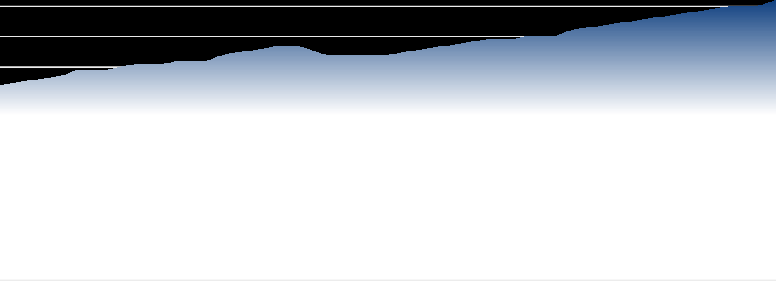
12 Million 3%
Forecasted

10 Million 2%

8 Million 1%

6 Million 0%

4 Million -1%

2 Million -2%

0 Million

1995 2000 2005 2010 2015 2020 2025 2030
-3%

Number of businesses (Million) Change (%)

Sources: IBISWorld

Year | Million | Change  (%)
1993 | 6.4 | N/A
1994 | 6.5 | 1.7
1995 | 6.6 | 1.5
1996 | 6.7 | 2.0
1997 | 6.9 | 2.2
1998 | 6.9 | 0.7
1999 | 7.0 | 1.0
2000 | 7.1 | 0.9
2001 | 7.1 | 0.4
2002 | 7.2 | 1.4
2003 | 7.3 | 0.7
2004 | 7.4 | 1.9
2005 | 7.5 | 1.5
2006 | 7.6 | 1.3
2007 | 7.7 | 1.4
2008 | 7.6 | -1.4
2009 | 7.4 | -2.2
2010 | 7.4 | -0.4

Year Million Change
(%)

2011 | 7.4 | -0.7
2012 | 7.4 | 1.1
2013 | 7.5 | 0.8
2014 | 7.6 | 0.9
2015 | 7.7 | 1.3
2016 | 7.8 | 1.3
2017 | 7.9 | 1.3
2018 | 7.9 | 0.6
2019 | 8.0 | 0.6
2020 | 8.0 | 0.5
2021 | 8.2 | 1.9
2022 | 8.3 | 1.8
2023 | 8.4 | 1.3
2024 | 8.5 | 1.2
2025 | 8.6 | 1.1
2026 | 8.7 | 1.0
2027 | 8.8 | 1.0
2028 | 8.9 | 1.0
2029 | 9.0 | 1.0
2030 | 9.1 | 1.0
2031 | 9.2 | 1.1

This driver refers to the total number of establishments in the United States with one or more employees. This data does not include businesses with no employees, which are also called non-employer businesses. The data for this report is sourced from the US Census Bureau and County Business Patterns.

Current Performance

In 2025, the number of businesses in the United States is estimated to reach 8.6 million, following a period of moderate expansion. Growth has persisted despite macroeconomic headwinds, but a gradual slowdown in the annual growth rate is evident. For the current year, business formation is supported by ongoing, though softening, consumer spending and continued, if uneven, economic recovery following the 2020 pandemic shock. However, inflationary pressures in 2025 are dampening consumer confidence, which may restrain the opening of new businesses, particularly among small firms sensitive to cost increases. The current climate also reflects a cautious investment environment, with business owners wary of rising operating expenses and financing costs.
Over the five years through 2025, the number of businesses in the United States increased at an estimated annualized rate of 1.5%. Growth sharply rebounded beginning in 2021, following the significant contraction in 2020 caused by the COVID-19 pandemic. The pandemic prompted widespread business closures and suppressed new business formation due to mandatory shutdowns, restricted mobility, and a collapse in consumer spending. Numerous businesses closed on a permanent basis, particularly in service sectors highly impacted by physical distancing requirements. However, the US economy experienced a rapid recovery in 2021, driven by pent-up consumer demand and substantial government stimulus. This enabled a strong uptick in new business formation and aided existing businesses in stabilizing or expanding operations. These positive trends continued into 2022 and 2023, although the pace of growth moderated as inflation accelerated and pandemic-era stimulus measures expired.
Macroeconomic factors such as tight labor markets, changing consumer behavior, and evolving credit conditions played a key role in shaping the business environment during this period. Access to affordable credit improved gradually following the initial shocks of 2020, supporting

business formation, but rising interest rates and inflation in later years introduced new risks for business sustainability and growth. Digital transformation intensified as businesses increasingly adopted e-commerce and remote work models to adapt to new market realities, creating opportunities for some sectors while challenging traditional business models.
From 2021 to 2025, improvements in private investment, gradual normalization in supply chains, and relative stability in broader economic indicators supported the ongoing, if moderate, growth in the number of businesses. Nonetheless, continued cost pressures, including wage growth and input price volatility, tempered the pace of new business openings, particularly among startups and small enterprises. Overall, the period was characterized by recovery from a deep contraction, adaptation to evolving consumer and market dynamics, and moderate business creation.

Outlook

In 2026, the number of businesses in the United States is forecast to increase by 1.0%, reaching 8.7 million. Economic growth is expected to remain steady, with a relatively stable labor market and only modest fluctuations in consumer spending. Persistent, though easing, inflation may limit robust acceleration in new business formation in the near term.
Over the five years through 2030, the number of US businesses is projected to rise at an average annual rate near 1.0%, reaching 9.1 million. Macroeconomic conditions such as US GDP growth and persistent declines in unemployment are likely to support ongoing business creation. However, rising operating costs, including increases in state and local minimum wages, will elevate the cost of doing business for smaller enterprises in particular. Ongoing supply chain adjustments and digital transformation will continue to frame opportunities for market entrants and incumbents. Inflationary pressures are anticipated to ease over the outlook period, but may continue to impact consumer and business confidence, especially if interest rates remain at elevated levels. Labor market dynamics, regulatory shifts, and evolving consumer preferences will also influence the rate of business formation and sustainability during the outlook period.

Government consumption and investment

Estimated Value in 2026

$4027.6 billion

2021-26 CAGR

2025-26 Change
Forecast Value in 2031

$4188.3 billion
1 .6 %
0 .9 %

2026-31 CAGR

2026-27 Change
0 .8 %
1 .2 %

Government consumption and investment
The percentage change in real household disposable income from 1980-2032
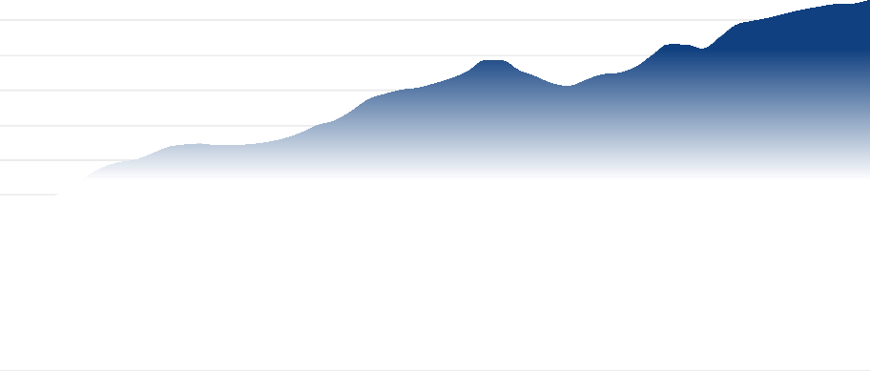
4,800 billion 8%
Forecasted

4,000 billion 6%

3,200 billion 4%

2,400 billion 2%

$1,600 billion 0%

$800 billion -2%

$0 billion -4%
1980 1985 1990 1995 2000 2005 2010 2015 2020 2025 2030

Government consumption and investment ($billion) Change (%)

Sources: IBISWorld

Year | $ billion | Change  (%)
1980 | 1853.9 | N/A
1981 | 1871.9 | 1.0
1982 | 1905.5 | 1.8
1983 | 1976.6 | 3.7
1984 | 2046.0 | 3.5
1985 | 2182.6 | 6.7
1986 | 2301.1 | 5.4
1987 | 2367.9 | 2.9
1988 | 2397.2 | 1.2
1989 | 2465.3 | 2.8
1990 | 2544.2 | 3.2
1991 | 2574.7 | 1.2
1992 | 2586.7 | 0.5
1993 | 2565.5 | -0.8
1994 | 2567.7 | 0.1
1995 | 2580.8 | 0.5
1996 | 2604.7 | 0.9
1997 | 2647.4 | 1.6
1998 | 2711.6 | 2.4
1999 | 2800.2 | 3.3
2000 | 2851.2 | 1.8
2001 | 2958.7 | 3.8
2002 | 3090.5 | 4.5
2003 | 3153.9 | 2.1
2004 | 3202.2 | 1.5
2005 | 3226.2 | 0.7
2006 | 3277.2 | 1.6
2007 | 3335.9 | 1.8
2008 | 3420.1 | 2.5
2009 | 3542.7 | 3.6
2010 | 3539.7 | -0.1
2011 | 3426.9 | -3.2
2012 | 3356.0 | -2.1
2013 | 3275.6 | -2.4
2014 | 3247.3 | -0.9

Year $ billion Change
(%)

2015 | 3313.6 | 2.0
2016 | 3378.5 | 2.0
2017 | 3397.1 | 0.6
2018 | 3465.0 | 2.0
2019 | 3600.4 | 3.9
2020 | 3722.7 | 3.4
2021 | 3718.6 | -0.1
2022 | 3672.7 | -1.2
2023 | 3800.7 | 3.5
2024 | 3945.3 | 3.8
2025 | 3991.1 | 1.2
2026 | 4027.6 | 0.9
2027 | 4077.1 | 1.2
2028 | 4119.6 | 1.0
2029 | 4155.1 | 0.9
2030 | 4183.2 | 0.7
2031 | 4188.3 | 0.1
2032 | 4234.4 | 1.1

Government consumption and investment tracks all inflation-adjusted spending by federal, state and local governments on goods, services and fixed assets for public use in the United States. Expressed in trillions of chained (2017) US dollars, this key indicator reflects outlays for administration, defense, public health, education, infrastructure and investments critical to economic and social stability.

Current Performance

Government consumption and investment are on a steady but moderating upswing in 2026, with outlays projected to rise 0.9% to $4.03 trillion as emergency-era volatility gives way to more routine budget execution and targeted program spending. Core drivers now include embedded infrastructure programs, elevated defense and security commitments and ongoing support for health, education and social services, even as headline growth cools from the post-pandemic rebound. Inflation, higher interest costs and tighter fiscal scrutiny are restraining the pace of new discretionary initiatives, but governments continue to prioritize resilience, digital service delivery and workforce-intensive public services.
Between 2021 and 2026, performance has pivoted from pandemic withdrawal to infrastructure- and resilience-led expansion. Spending dipped by 0.1% in 2021 and 1.2% in 2022 as large federal relief packages, expanded unemployment insurance and emergency health funding began to roll off, while state and local governments struggled with lagging revenues, rising wage demands and service backlogs.
From 2023 onward, major federal infrastructure laws translated into on-the-ground projects in transport, water, broadband and climate adaptation, lifting investment and supporting 3.5% and 3.8% in 2023 and 2024, respectively. Defense modernization, cybersecurity and border security kept federal spending elevated, while state and local budgets leaned into K-12 remediation, higher education stabilization, public safety and reopening-related staffing. At the same time, governments faced persistent headwinds from public-sector labor shortages, construction bottlenecks and higher materials costs, which slowed project execution and tempered the potential upside from legislated spending pipelines. Demographic pressures from an aging population and a growing need for behavioral health and social services also pushed operating expenditures higher, reinforcing the shift toward health and human services as structural anchors of government demand.

Outlook

In the first forecast year, 2027, growth in government consumption and investment stays positive but edges lower, with spending projected to rise at a modest 1.2% to $4.08 trillion as legacy infrastructure programs peak and discretionary space narrows under higher debt-service costs. Policy makers still channel resources into defense readiness, border enforcement, health capacity and education, but increasingly prioritize

asset maintenance, targeted climate resilience and digital modernization over large new program launches.
Across the 2027–2031 period, government expenditure maintains an upward trajectory, with annual gains slowing toward the end of the outlook period, pushing the driver to $4.19 trillion. Infrastructure outlays shift from greenfield construction toward hardening existing assets against climate risk, funding coastal protection, wildfire mitigation and grid resilience, while ongoing investments in AI, cybersecurity and cloud infrastructure reshape government operations. Rising healthcare and pension obligations, combined with higher borrowing costs, place structural pressure on budgets and threaten to crowd out some discretionary capital projects, particularly at the state and local level. Even so, demographic aging, public safety demands and geopolitical uncertainty keep baseline consumption and investment elevated, ensuring government remains a stabilizing share of aggregate demand even as it slightly declines as a percentage of GDP and becomes more tightly focused on resilience, care infrastructure and strategic competitiveness.

Aggregate private investment

Estimated Value in 2026

$4591.1 billion

2021-26 CAGR

2025-26 Change
Forecast Value in 2031

$5390.8 billion
3 .1 %
3 .5 %

2026-31 CAGR

2026-27 Change
3 .3 %
3 .4 %

Aggregate private investment
The percentage change in real household disposable income from 1980-2032
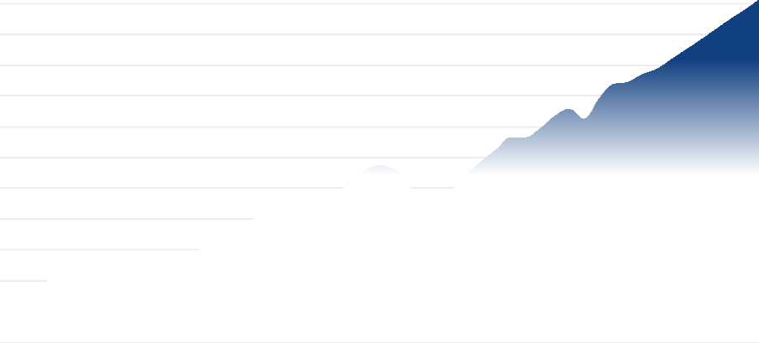
6,000 billion
Forecasted

30%

5,000 billion 20%

4,000 billion 10%

3,000 billion 0%

2,000 billion -10%

1,000 billion -20%

$0 billion -30%
1980 1985 1990 1995 2000 2005 2010 2015 2020 2025 2030

Aggregate private investment ($billion) Change (%)

Sources: IBISWorld

Year | $ billion | Change  (%)
1980 | 900.3 | N/A
1981 | 979.5 | 8.8
1982 | 856.5 | -12.6
1983 | 936.4 | 9.3
1984 | 1191.9 | 27.3

1985 | 1191.2 | -0.1
1986 | 1193.1 | 0.2
1987 | 1227.0 | 2.8
1988 | 1257.2 | 2.5
1989 | 1308.1 | 4.0
1990 | 1274.3 | -2.6
1991 | 1190.0 | -6.6
1992 | 1276.7 | 7.3
1993 | 1378.8 | 8.0
1994 | 1541.9 | 11.8
1995 | 1591.4 | 3.2
1996 | 1730.5 | 8.7
1997 | 1927.8 | 11.4
1998 | 2111.5 | 9.5
1999 | 2290.7 | 8.5
2000 | 2444.9 | 6.7
2001 | 2307.4 | -5.6
2002 | 2287.7 | -0.9
2003 | 2386.4 | 4.3
2004 | 2607.0 | 9.2
2005 | 2782.2 | 6.7
2006 | 2867.9 | 3.1
2007 | 2796.0 | -2.5
2008 | 2564.3 | -8.3
2009 | 2025.3 | -21.0
2010 | 2309.0 | 14.0
2011 | 2463.1 | 6.7
2012 | 2735.3 | 11.1
2013 | 2938.7 | 7.4
2014 | 3129.0 | 6.5
2015 | 3323.4 | 6.2
2016 | 3320.2 | -0.1
2017 | 3467.7 | 4.4
2018 | 3668.1 | 5.8
2019 | 3784.0 | 3.2
2020 | 3618.6 | -4.4

2021 | 3944.4 | 9.0
2022 | 4184.9 | 6.1
2023 | 4219.5 | 0.8
2024 | 4346.5 | 3.0
2025 | 4434.6 | 2.0
2026 | 4591.1 | 3.5
2027 | 4747.2 | 3.4
2028 | 4906.1 | 3.3
2029 | 5070.3 | 3.3
2030 | 5237.4 | 3.3
2031 | 5390.8 | 2.9
2032 | 5558.6 | 3.1

Aggregate private investment, or private fixed investment, includes spending by individuals and businesses on physical structures, equipment and software. It is different from gross domestic investment because it does not include investment by the government. Aggregate private investment is typically broken down into residential and nonresidential components, which in turn are comprised of physical structures, equipment and software, as well as changes in inventory levels. Intermediate inputs, which become part of the final product, are not included in investment. The data for this report is sourced from the Bureau of Economic Analysis and presented in chained 2017 dollars.

Current Performance

Aggregate private investment is estimated to reach $4,591.1 trillion in 2026, with a growth of 3.1% for the year. This growth is sustained by ongoing interest rate cuts initiated by the Federal Reserve in 2024. However, positive momentum is counterbalanced by heightened inflationary pressures due to new tariffs on goods from Mexico, Canada and especially China. These tariffs, imposed by the Trump Administration, have increased production costs, discouraging discretionary and expansionary investments. Businesses and consumers are responding to ongoing price uncertainty and global economic volatility with caution, keeping the growth rate of aggregate private investment moderate.
Over the five years leading to 2026, aggregate private investment has shown notable volatility and resilience. In 2021, a robust economic rebound and low mortgage rates spurred significant growth in residential construction, supporting an 9.0% annual increase. Investment continued to grow in 2022 by 6.1%, even amidst inflation levels not seen since the early 1980s. The Federal Reserve responded with several interest rate hikes as geopolitical instability increased energy prices. Despite challenges, confidence in the underlying economy sustained private investment growth. Persistent high interest rates in 2023 tempered further growth, with a marginal increase of 0.8% in aggregate private investment as tighter monetary policy took effect. The Federal Reserve's interest rate cuts in 2024 provided some relief, but benefits have been gradual.
Macroeconomic headwinds like rapidly changing monetary policies, supply chain volatility, and shifting corporate confidence have dominated the investment environment throughout this period. Business investment, comprising 60.0% to 80.0% of aggregate private investment, has been highly sensitive to borrowing costs and long-term policy risks. Large swings in energy prices and global commodity markets have influenced nonresidential investment, while the residential segment expanded during low interest rates but plateaued as borrowing became costlier.
Overall, aggregate private investment displayed moderate growth from 2021 to 2026, increasing at an average annual rate of 3.1%. The performance reflects the interplay between monetary tightening, shifting global conditions, and periodic regulatory interventions.

Outlook

Private investment is projected to increase by 3.4% in 2027. Continued interest rate cuts are expected to facilitate access to capital and encourage investment activity. Growth is anticipated to remain steady but moderate as policymakers remain cautious amidst persistent inflation risks and trade tensions.
Over the five years to 2031, aggregate private investment is forecast to grow to $5,390.8 trillion. The investment environment will be influenced by political dynamics, such as relations with China, Iran, and Russia, and potential shifts toward protectionist trade policies. These uncertainties could constrain business investments, particularly in capital-intensive industries. However, anticipated large-scale infrastructure projects are expected to channel private capital into both nonresidential and residential investment, providing a boost.
Other macro trends, including deregulation and corporate tax policy changes, are expected to favor private sector investment. With relatively

low borrowing costs and pro-investment policies, firms may be more inclined to invest in equipment, software, and building projects. Nonetheless, risks related to inflation, global supply chain disruptions, and economic policy shifts remain relevant constraints to robust expansion.

Corporate profit

Estimated Value in 2026

$4271.8 billion

2021-26 CAGR

2025-26 Change
Forecast Value in 2031

$5602.2 billion
6 .6 %
3 .9 %

2026-31 CAGR

2026-27 Change
5 .6 %
6 .1 %

Corporate profit
The percentage change in real household disposable income from 1980-2032
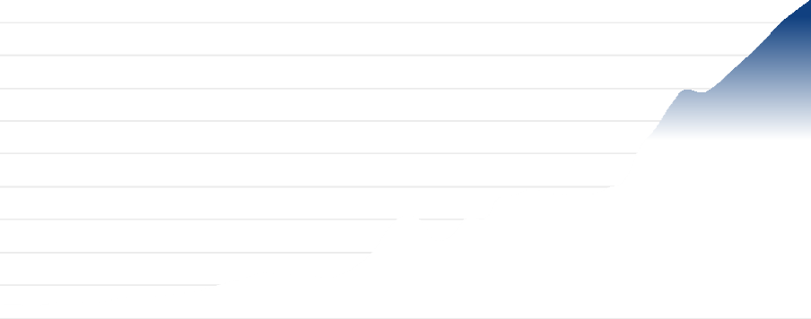
7,200 billion
Forecasted

48%

6,000 billion 36%

4,800 billion 24%

3,600 billion 12%

2,400 billion 0%

$1,200 billion -12%

$0 billion -24%
1980 1985 1990 1995 2000 2005 2010 2015 2020 2025 2030

Corporate profit ($billion) Change (%)

Sources: IBISWorld

Year | $ billion | Change  (%)
1980 | 240.2 | N/A
1981 | 250.4 | 4.3
1982 | 222.7 | -11.1
1983 | 254.6 | 14.3
1984 | 293.6 | 15.3
1985 | 288.3 | -1.8
1986 | 272.4 | -5.5
1987 | 319.4 | 17.2
1988 | 368.0 | 15.2

1989 | 377.5 | 2.6
1990 | 392.8 | 4.0
1991 | 430.4 | 9.6
1992 | 463.9 | 7.8
1993 | 508.1 | 9.5
1994 | 598.6 | 17.8
1995 | 677.4 | 13.2
1996 | 755.9 | 11.6
1997 | 831.1 | 10.0
1998 | 770.5 | -7.3
1999 | 793.8 | 3.0
2000 | 769.6 | -3.0
2001 | 725.6 | -5.7
2002 | 815.7 | 12.4
2003 | 976.1 | 19.7
2004 | 1248.3 | 27.9
2005 | 1670.2 | 33.8
2006 | 1861.7 | 11.5
2007 | 1770.5 | -4.9
2008 | 1403.9 | -20.7
2009 | 1508.3 | 7.4
2010 | 1831.1 | 21.4
2011 | 1802.2 | -1.6
2012 | 2203.9 | 22.3
2013 | 2234.1 | 1.4
2014 | 2356.1 | 5.5
2015 | 2295.5 | -2.6
2016 | 2245.2 | -2.2
2017 | 2247.5 | 0.1
2018 | 2266.6 | 0.8
2019 | 2376.0 | 4.8
2020 | 2503.8 | 5.4
2021 | 3110.4 | 24.2
2022 | 3445.9 | 10.8
2023 | 3888.2 | 12.8
2024 | 4170.2 | 7.3

2025 | 4112.3 | -1.4
2026 | 4271.8 | 3.9
2027 | 4533.3 | 6.1
2028 | 4787.1 | 5.6
2029 | 5067.2 | 5.8
2030 | 5371.2 | 6.0
2031 | 5602.2 | 4.3
2032 | 5811.5 | 3.7

This item refers to corporate profit earned across all industries. Profit is calculated by subtracting the value of the following from revenue: wages after inventory valuation and capital consumption adjustments. Data is sourced from the Bureau of Economic Analysis and is presented in 2017 dollars.

Current Performance

Corporate profit is anticipated to decrease by 3.9% in 2026, reaching $4,271.83 billion. Interest rate cuts toward the end of 2024 and in 2025 are expected to lower financing costs and bolster business investment. Steady consumer demand, resilient job markets and record-level earnings from large technology firms will support profit. However, tariffs are projected to raise input costs for businesses reliant on imports, limiting profit gains.
From 2021 through 2026, corporate profit has shown robust recovery and subsequent moderation. Margins remained resilient despite ongoing supply chain disruptions from the COVID-19 pandemic and rising inflation. In 2021, profit rebounded significantly, expanding by 24.2% as economic activity accelerated. Growth continued at 10.8% in 2022 as companies passed higher costs onto consumers, maintaining robust margins despite inflationary pressure. In 2023, profit increased by 9.9%, with interest rate hikes beginning to temper consumption and raise borrowing expenses, but strong performances among large technology companies continued to drive growth.
By 2024, high interest rates persisted, but resilient labor markets and strong consumer spending sustained an estimated 7.3% growth in profit. Monetary policy began to shift in late 2024, with rate cuts easing pressure on corporate financing. Macroeconomic trends like digital technology adoption, globalized supply chains and productivity enhancements contributed to profit stability. Meanwhile, cost pressures from labor and energy markets, as well as shifting trade and tariff regimes, intermittently constrained growth.
From 2020 to 2025, corporate profit grew at a CAGR of 10.1%, reflecting a post-pandemic rebound followed by normalization as disruptions waned. Macro trends, including strong consumer demand, capital investment in technology and labor market adjustments, played critical roles. However, evolving tariffs, global supply chain shifts and persistent inflation underscored ongoing risks to profit.

Outlook

Corporate profit is forecast to increase by 6.1% in 2027. AI-driven efficiency gains are a leading catalyst for US corporate profit growth heading into 2027. Strong earnings are set to be powered by positive operating leverage, AI-fueled productivity, accommodating tax and regulatory policy and increased M&A activity, particularly benefiting financials, industrials and healthcare.
From 2025 to 2031, corporate profit levels are expected to grow, with profit expect to reach $5,602.17 billion by 2031. Deregulatory measures may create a more business-friendly environment, but these benefits could be offset by rising operational costs tied to tariffs, labor expenses, and regulatory compliance. Companies may increase domestic production and invest in automation, though high initial costs will temper immediate profitability gains. Labor union activity is anticipated to pressure wages, further constraining growth.
Shifts in tax policy, with some states lowering corporate tax rates, may slightly ease the corporate tax burden. Firms might recapture increased costs through higher prices for goods and services, but consumer tolerance for price increases may be tested amid inflation expectations and economic uncertainty. Over the next five years, profit expansion will be limited by these converging trends, despite opportunities for growth among firms investing in efficiency improvements and automation.

Business sentiment index

Estimated Value in 2026

48.6 Index

2021-26 CAGR

2025-26 Change
Forecast Value in 2031

49.2 Index
- 4.3 %
- 0.7 %

2026-31 CAGR

2026-27 Change
0 .3 %
0 .8 %

Business sentiment index
The percentage change in real household disposable income from 1980-2032
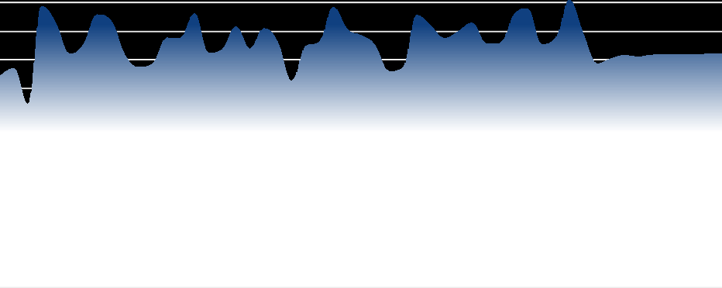
72 Index
Forecasted

60%

60 Index 45%

48 Index 30%

36 Index 15%

24 Index 0%

12 Index -15%

0 Index -30%
1980 1985 1990 1995 2000 2005 2010 2015 2020 2025 2030

Business sentiment index (Index) Change (%)

Sources: IBISWorld

Year | Index | Change  (%)
1980 | 44.5 | N/A
1981 | 46.2 | 3.8
1982 | 38.5 | -16.8
1983 | 59.3 | 54.1
1984 | 55.8 | -6.0
1985 | 49.2 | -11.8
1986 | 51.1 | 3.8
1987 | 57.5 | 12.6
1988 | 56.2 | -2.2
1989 | 48.9 | -13.0
1990 | 46.5 | -5.1

1991 | 47.1 | 1.3
1992 | 52.6 | 11.8
1993 | 52.5 | -0.3
1994 | 57.8 | 10.2
1995 | 49.5 | -14.5
1996 | 50.1 | 1.3
1997 | 55.0 | 9.7
1998 | 50.2 | -8.7
1999 | 54.6 | 8.8
2000 | 51.7 | -5.4
2001 | 43.4 | -16.0
2002 | 50.8 | 17.1
2003 | 51.7 | 1.8
2004 | 59.1 | 14.3
2005 | 54.4 | -7.9
2006 | 53.1 | -2.4
2007 | 51.1 | -3.8
2008 | 45.5 | -10.9
2009 | 46.2 | 1.5
2010 | 57.4 | 24.2
2011 | 55.2 | -3.9
2012 | 52.5 | -4.8
2013 | 53.9 | 2.6
2014 | 55.8 | 3.5
2015 | 51.4 | -7.9
2016 | 51.4 | 0.1
2017 | 57.4 | 11.7
2018 | 58.8 | 2.3
2019 | 51.3 | -12.8
2020 | 52.5 | 2.4
2021 | 60.6 | 15.4
2022 | 53.5 | -11.6
2023 | 47.1 | -12.1
2024 | 48.3 | 2.5
2025 | 48.9 | 1.4
2026 | 48.6 | -0.7

2027 | 49.0 | 0.8
2028 | 49.0 | 0.1
2029 | 49.1 | 0.2
2030 | 49.1 | 0.2
2031 | 49.2 | 0.2
2032 | 49.3 | 0.2

The business sentiment index gauges the overall health of the business environment by reviewing production levels, inventory levels, supply deliveries and employment levels. This driver is sourced from the Institute of Supply Management's United States Business Confidence index.

Current Performance

The business sentiment index is estimated to reach 48.6 in 2026, representing an decrease of -0.7% from the previous year. This level remains below the neutral threshold of 50.0, indicating that overall business confidence continues to reflect mild contraction within the US business sector. Uncertainty around tariff policy and international relations, including the conflict in Iran, are driving down sentiment. Deregulatory initiatives by the Trump administration aim to foster domestic investment and boost manufacturing, but the business sector remains cautious in anticipation of further policy developments. Falling interest rates have provided some relief to businesses by reducing borrowing costs and enabling reinvestment in previously stalled projects.
Over the five years to 2025, business sentiment has experienced pronounced volatility, driven by several significant macroeconomic events. The index surged to 60.6 in 2021, driven by the rollout of COVID-19 vaccines and the lifting of lockdown mandates, which reignited economic activity and unleashed pent-up demand, particularly for services. However, this rebound was not sustained; in 2022, surging inflation prompted the Federal Reserve to aggressively raise interest rates, while the Russian invasion of Ukraine increased geopolitical tensions and uncertainty. The index dropped 11.6% to 53.5 in 2022 as a result. Small businesses were disproportionately affected by rising costs and rate hikes, while larger firms managed better but also faced declining sentiment. In 2023, persistent inflation and elevated interest rates continued to hamper confidence. Although consumer spending remained resilient, high operating costs weighed on business budgets and sentiment declined a further 12.1%, reaching 47.1.
Growth resumed in 2024, when the index rose by 2.5%, buoyed by early signs of declining interest rates that rekindled some business optimism. However, macroeconomic uncertainty persisted, characterized by an environment of fluctuating inflation rates, uncertain monetary policy, and ongoing trade negotiations. Supply chain pressures and global political tensions remained relevant, adding to business caution. Despite these headwinds, the resilience of consumer spending played a stabilizing role, preventing more significant declines in business sentiment.
During the five years to 2026, the business sentiment index declined at a CAGR of -4.3%. This period was marked by extreme swings from pandemic-driven rebound to new pressures arising from inflation, monetary tightening, and geopolitical shocks. Volatility became an enduring feature, as sentiment responded acutely to changing costs of capital, policy signals and global uncertainties. Broader macro trends, including shifts in supply chain strategies, policy responses to sustainability and climate risk, and an evolving international trade landscape, all contributed to the uncertain outlook and weighed on business sentiment throughout the period.

Outlook

The business sentiment index is projected to rise to 48.9 in 2026. This uptick will be mainly attributed to further declines in interest rates, easing financial pressures, and ongoing recovery in global supply chains, which will aid business planning and investment.
Over the five years to 2031, IBISWorld projects the business sentiment index will continue to rise, reaching 49.2 by 2031. Sentiment is expected to improve gradually, with volatility remaining present but easing compared to the prior period. Influences on sentiment will include moderating inflation, more stable monetary policy, and clarity in trade and tariff environments. Continual resolution of supply chain disruptions will further boost confidence, but external factors such as regional conflict, federal deficit levels, and shifting sanction policies may periodically dampen sentiment, causing short-term fluctuations. The resilience of consumer demand and gradual global economic health recovery are expected to underpin a return to modest expansion in business sector confidence throughout the period.

Risk Score Methodology

What is Industry Risk?
Industry risk is the difficulty or otherwise of operating in an industry. We calculate industry risk using non-financial information. We represent industry risk with forward-looking numerical scores for specific industries. Industry Risk Scores measure the expected risk for the upcoming 12 to 18 months.

Industry Risk Scoring Methodology
We represent industry risk on a scale of 1 to 9, where 1 represents the lowest risk, and 9 is the highest risk.Industry risk is broken down into Growth, Structure and Sensitivity risk, which are combined to calculate the overall risk score.

Growth: Growth risk is a combination of recent and forecast growth scores. Growth scores account for between 0 and 25% of the overall score.The base case contribution is 25%, which is dampened at inflection points where extreme declines produce misleading positive forecast growth.

Structure: We calculate structural risk by analyzing internal industry risk factors.These factors are an industry's volatility, barriers to entry, external assistance, trade exposure, imports and exports (if any), industry life cycle and amount of competition. When our analysis identifies that an external factor creates a transitory shift to industry structure, the ratings are subjected to a structural adjustment score. The structure score contributes 25% plus any contribution dampened from the growth score.

Sensitivity: We calculate sensitivity risk by examining external and exogenous factors that affect risk within the industry.Examples include input costs, number of housing starts, commodity prices, etc.This component contributes to 50% of the overall score.

Risk Rating Score Ranges

Very Low | Low | Medium-Low | Moderate | Medium-High | High | Very High
1.0-3.0 | 3.0-4.1 | 4.1-4.7 | 4.7-5.3 | 5.3-5.9 | 5.9-7.0 | 7.0-9.0

IBISWorld helps you find the industry information you need - fast.

Disclaimer
This product has been supplied by IBISWorld Inc. ('IBISWorld') solely for use by its authorized licenses strictly in accordance with their license agreements with IBISWorld. IBISWorld makes no representation to any other person with regard to the completeness or accuracy of the data or information contained herein, and it accepts no responsibility and disclaims all liability (save for liability which cannot be lawfully disclaimed) for loss or damage whatsoever suffered or incurred by any other person resulting from the use of, or reliance upon, the data or information contained herein. Copyright in this publication is owned by IBISWorld Inc. The publication is sold on the basis that the purchaser agrees not to copy the material contained within it for other than the purchasers own purposes. In the event that the purchaser uses or quotes from the material in this publication – in papers, reports, or opinions prepared for any other person – it is agreed that it will be sourced to: IBISWorld Inc. by IBISWorld on 10 August 2019 in accordance with their license agreement in IBISWorld

2026 IBISWorld. All Rights Reserved www.ibisworld.com

